Tinker cad Assignment
Yogeshwari A

Arduino Uno connects via USB to a breadboard holding 5 coloured LEDs (red, green, yellow, orange) in sequence. Each LED's anode goes through a 220Ω resistor (brown-red-brown bands) to individual digital pins, while cathodes share a ground rail. Jumper wires link power, ground, and signal paths.
Components Used
- Arduino Uno (1) - Microcontroller board
- Breadboard (1) - Prototyping platform
- LEDs (5) - Multi-color display elements
- Resistors (5) - 220Ω current limiters
- Jumper Wires (12+) - Circuit connections
- USB Cable (1) - 5V power source

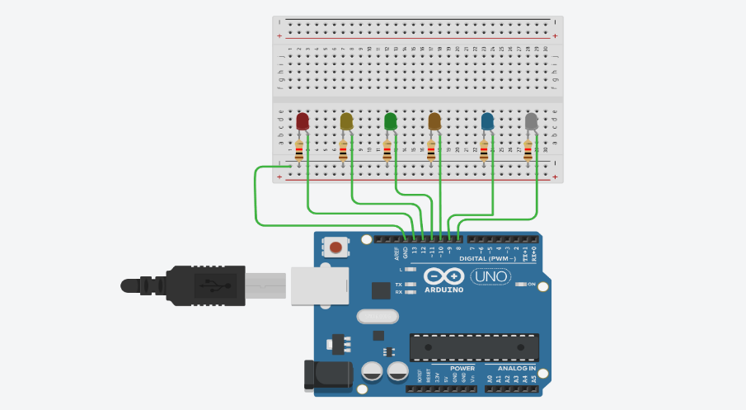
Outcomes
- Master pin Mode (), digital Write () for precise LED control.
- Apply delay (200) timing for 0.2-second sequential activation.
- Use arrays int led Pins [] = {2,3,4,5,6} for scalable pin management.
- Implement for loops to automate LED chasing pattern.
- Understand resistor importance (prevents LED/Arduino damage from excess current).
- Gain Tinker cad proficiency: wiring, coding, simulation, debugging.

